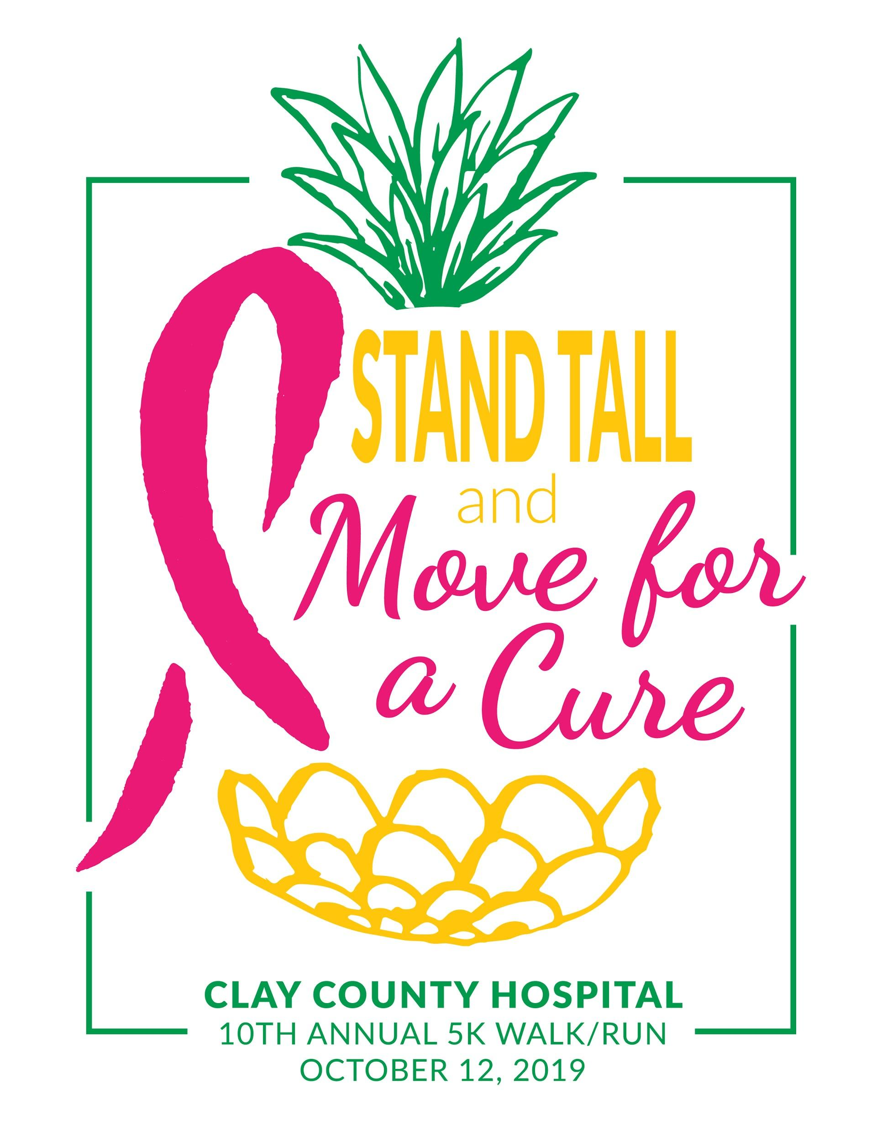

October is National Breast Cancer Awareness Month.

Clay County Hospital is proud to announce its support in increasing awareness of the importance of prevention, early detection and treatment of breast cancer. CCH encourages the community to work together by participating on Saturday, October 12th during our 10th annual “Move For The Cure 5K Walk/Run.” All proceeds will be donated to the Clay County Cancer Support Group & Clay County Crusaders. Race starts at 8AM from FES (FLORA ELEMENTARY SCHOOL). The 2019 Family Fun Fest will follow at 9:30am in the FES gym and outside the gym. Food stands, free hot dogs and bounce houses will also be there.

We are looking for sponsors to assist in our 5k event.

Sponsor Levels

Gold $250 Silver $125.00 Bronze $50.00

Gold Sponsorship includes: Name included on different marketing materials such as radio and print, race event signage, banner at race and Logo on back of event shirt. Receives a free t-shirt.
Silver Sponsorship includes: Race event signage (Business name on race event signage at race), and business name on back of event shirt.
Bronze Sponsorship includes: Business name on event shirt.

Yes We Would Like To Sponsor the 5K!!!!!!! IF your entry will be late please call with the INFO!
Business Name: __________________________________ Level:__________ (Gold - shirt size _____)
E-mail Address:__________________________________
Signature: _______________________________________ Date:___________

Please submit no later than Sept 25th OR Mail to Clay County Hospital ATTN:
Radiology Dept. Attn: Tisha Kitley
911 Stacy Burk Drive Flora, IL 62839
Phone 618-662-1636 or Fax to 618-662-1489 OR CELL 618-508-3635

